**Bahria University, Lahore Campus**

Department of Computer Sciences

Lab Journal 10

**(Spring 2022)**

|  |  |  |
| --- | --- | --- |
| Course: | **Data Communication and Networks Lab** | Date: |
| Course Code: | CEL - 222 | Max Marks: 10 |
| Faculty’s Name: |  | Lab Engineer: |

Name: ALI HASSAN Enroll No: 03-13521-005

Objective(s) :

Students will observe the conversion of a URL to an IP address.

## Lab Tasks :

**Task 01: Write the steps for DNS conversion using ping command.**

Step 1: The client makes a domain name resolution request to the nearby domain name server.

Step 2: The local domain name server checks the local cache after receiving the request. The local domain name server instantly provides the search result if this record is present.

Step 3: If the record is missing from the local cache, the local domain name server forwards the request straight to the root domain name server, which then delivers the principal domain name of the local domain name server's domain (the subdomain of the root). The server's address.

Step 4: The local server queries its own cache after sending a request to the domain name server that was returned in the previous phase. It returns the address of the appropriate lower-level domain name server if there is no such record.

Step 5: Up until you locate the right record, repeat step 4.

Step 6: The local domain name server sends the client the results after saving them to the cache for later use.

**Task 02: Implement DNS in Packet Tracer according to the topology given below.**

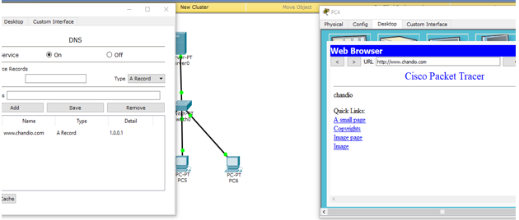

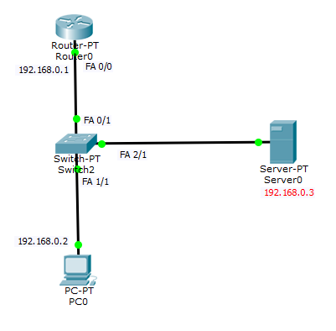

**Lab Grading Sheet :**

|  |  |  |  |
| --- | --- | --- | --- |
| **Task** | **Max Marks** | **Obtained Marks** | **Comments(*if any*)** |
| 1. | 5 |  |  |
| 2. | 5 |  |  |
| **Total** | **10** |  | **Signature** |

# Note : Attempt all tasks and get them checked by your Lab. Instructor